Java SE Project

Training And Placement Application

***HrRemoveJobFrame Documentation***

1. **HrRemoveJobFrame -**

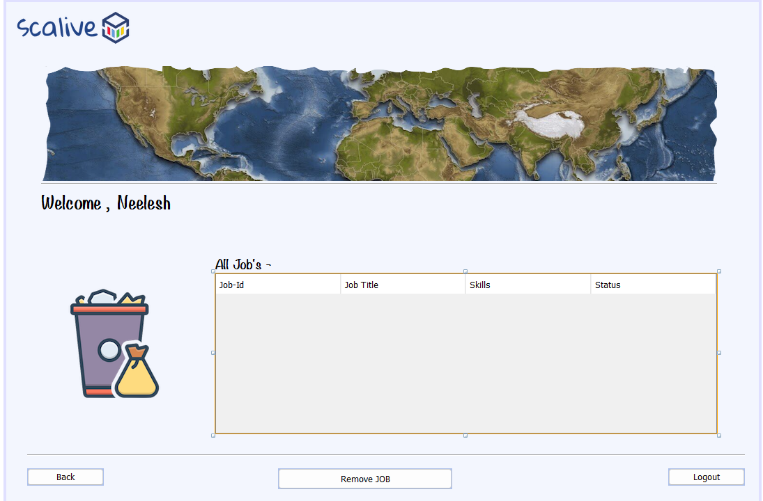

**2. STEPS TO BE DONE IN** **HrRemoveJobFrame**

In the **HrRemoveJobFrame** we need to do following steps:

1. Displaying the **Username**
2. Allow the user to **logout**
3. Allow the user to **go back**
4. Write code for removing the **JOB**
5. **Displaying The Username**

Same as before

1. **Allowing The User To Logout**

Same as before

1. **Allowing The User To Go Back**

Same as before

1. **Writing Code For Removing JOB**

**WRITING THE CODE IN JobDAO**

**Returning All JobList**

To return a **list of all Jobs** we must define a method in **JobDAO** called **getAllJobsByCurrentHr()**.

This method should return JOBID,JOBTITLE,TAGS and STATUS of all JOBS by the currently logged in HR from the DB

So the prototype of the method is:

**public static List<JobPojo> getAllJobsByCurrentHr(String hrId)throws SQLException**

**The Code For getAllJobsByCurrentHr()**

**//Write The Code**

**Coding removeJobByJobId() method in JobDAO**

**public static boolean removeJobByJobId(String jobId) throws SQLException**

**{**

**//Write The Code**

**}**

**The Code For Frame**

**public class HrRemoveJobFrame extends javax.swing.JFrame {**

**//Write The Code**